Aint318 Coursework

Student ID 1055660

Date: 11/12/2019

Contents

Introduction 2

1. Training Data Generation: 3

1.1 Display workspace of revolute arm 3

Code: 3

Output: 4

What can you say about the useful range of this arm? 4

1.2. Configurations of a revolute arm 4

Code 4

Graph 5

2. Implement 2-layer network 5

2.1 Implement the network feedforward pass 5

Inline function 5

internal functions 6

2.2. Implement 2-layer network training 6

2.3 Train network inverse kinematics 7

Internal Functions 7

Plot 8

2.4. Test and interpret inverse model 8

Neural network output 8

Significance of this Plot: 9

Are there better datasets to interpret inverse model performance? 9

How can you make the dataset more representative of the maze task? 9

Inline code 9

Inline code and plots for smaller sample size 11

3. Path Through a Maze 13

Game board: 13

Set Starting State and Blocked Locations 14

3.1 Random start state 14

Histogram: 14

Comment on how the displayed state occurrences align with the maze. 14

Inline code 15

3.2 Build a Reward Function 15

Inline code 15

3.3. Generate the transition matrix (5 marks) 16

Inline Code: 16

3.4 Initialize Q values 17

Inline code: 17

3.5 Implement Q-Learning Algorithm 17

Inline Code: 17

3.6 Run Q-Learning 19

Graph: 19

Observations: 19

Inline code: 19

3.7. Exploitation of Q-values 21

Graph 21

Inline code 21

4.Move Arm Endpoint Through Maze 22

4.1. Generate kinematic control to revolute arm 22

Non animated arm motion: 22

Inline code: 22

4.2 Animated revolute arm movement 24

Inline code 24

# Introduction

The purpose of this coursework is to explore the implementation of reinforcement learning through QLearning, and supervised learning through Neural Networks. I will be applying these concepts to a task where I aim to move an 2D 2 joint arm through a maze.

The QLearning algorithm will implement an epsilon-greedy selection policy to find the optimal solution through an assigned maze. This path will act as coordinates for the inverse kinematics that the arm will follow.

The inverse kinematics will be calculated by the 2 layer neural network. It will use resultant arm positions as an input and the joint angles as a target, so that it can determine the relationship between the endpoints and joint angles to do the inverse of the forwards kinematics.

Once the arm network, and the maze pathfinder are both trained, they will be implemented in tandem. The arm will move through the maze, which has been scaled to its usable area.

# 1. Training Data Generation:

## 1.1 Display workspace of revolute arm

### Code:

clc

close all

clear all

origin = [0;0]; %base frame of kinematics

length = [0.4,0.4]; % length of links

samples = rand([2,1000])*pi; % generate 1000 random angles from 0 to pi for each joint

[P1,P2] = RevoluteForwardKinematics2D(length,samples,origin); %P1 is midpoint P2 is end point

%%Plot results:

figure

hold on

axis equal

title("1055660: Arm Endpoint")

xlabel('x[m]')

ylabel('y[m]')

plot(0,0,'*')

plot(P2(1,:),P2(2,:),'.')

legend ('Origin','Endpoint')

### Output:

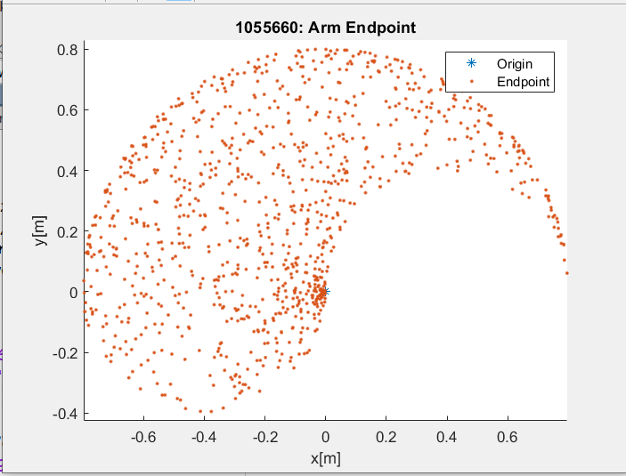

### What can you say about the useful range of this arm?

There are limits to the motion of the endpoint as it moves away from the origin. It may be a good idea to scale the maze inside the main area of this range.

## 1.2. Configurations of a revolute arm

### Code

clc

close all

clear all

origin = [0;0]; %base frame of kinematics

length = [0.4,0.4]; % length of links

samples = 10;

data = rand([2,1000])*pi; % generate 1000 random angles from 0 to pi for each joint

[P1,P2] = RevoluteForwardKinematics2D(length,data,origin); %P1 is midpoint P2 is end point

figure

hold on

axis equal

title("1055660: Arm Configuration")

xlabel('x[m]')

ylabel('y[m]')

for i = 1:samples

x = [0,P1(1,i),P2(1,i)];

y =[0,P1(2,i),P2(2,i)];

plot(x,y,'-ob')

end

### Graph

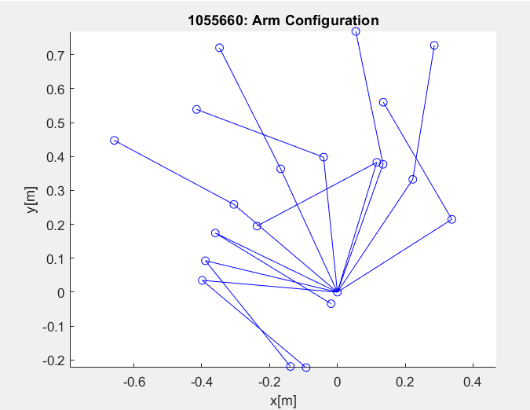

# 2. Implement 2-layer network

## 2.1 Implement the network feedforward pass

### Inline function

function [activation,a2] = feedForwardPass(weight1, weight2, input)

input= augment(input);%augment input

net = weight1*input;

a2 = arrayfun(@sigmoid,net);%calculate sigmoid activation for layer 1 (elementwise)

a2Hat = augment(a2);% augment a2

activation =weight2*a2Hat;%calculate linear output activation

end

### internal functions

function [output] = augment (input)

%a function to append a row of ones to a matrix

[~,columns] = size(input);% get the number of columns of the matrix

output = [input;ones(1,columns)];%append a row of ones with an equal number of columns

end

function [output] = sigmoid(input)

%a function to calculate the sigmoid input of a single element

output = 1/(1+exp(-input));

end

## 2.2. Implement 2-layer network training

function [weight1, weight2,outError] = Training(weight1, weight2,learningRate, input, target)

%A batchwise function to tune the weights of the network and return the

%error

[O, a2]= feedForwardPass(weight1, weight2, input);% get the output and internal activations

outDelta = -(target-O); %calculate the delta term of the output layer (non-sigmoid)

weightHat = weight2(:,1:end-1);%get the weight without the bias term

backProp = (weightHat'*outDelta).*(a2.*(1-a2));% calculate the back propagation of the error

%calculate the Error Gradients for the weights

errorGradientWeight1=backProp*augment(input)';

errorGradientWeight2=outDelta*augment(a2)';

%update weights with the error

weight1 = weight1 - learningRate.*errorGradientWeight1;

weight2 = weight2 -learningRate.*errorGradientWeight2;

%calculate the error and update the array

e = outDelta.^2;

outError = e(1,:) + e(2,:);

end

## 2.3 Train network inverse kinematics

clc

close all

clear all

origin = [0;0]; %base frame of kinematics

length = [0.4,0.4]; % length of links

samples = 1000;% the number of samples used for training and testing

hidden = 12;%the number of hidden layers

input = 2;% number of system inputs

output = 2;% number of system outputs on the final layer

learningRate =0.001;

iterations = 50000;%number of times the network will be trained( a total of 50,000,000 data points will be used to train it)

[weight1, weight2]=makeWeights(output,hidden, input);% generate the weight matrices

for i = 1:iterations

%each iteration, a new set of training data will be generated. This

%will help the network generalize as it won’t be tuned to a specific

%dataset

targetData = rand([2,samples])*pi; % generate 1000 random angles from 0 to pi for each joint

[~,inputs] = RevoluteForwardKinematics2D(length,targetData,origin);%get the endpoint positions from the forward

%kinematics to be used as inputs for the inverse

[weight1, weight2,error]=Training(weight1, weight2,learningRate, inputs, targetData);%update the trained weights and output error matrix

meanError(i)=mean(error);% append the mean of the error matrix for future plotting

end

figure

hold on

title("1055660: Mean Error")

xlabel('Trials')

ylabel('Error')

plot(meanError)

### Internal Functions

function [weight1, weight2] = makeWeights(outputs, hidden, inputs)

%make the weight1 matrix where it is size (inputs+bias)X#ofHiddenLayers

%%inputs is the X and Y coordinates of the endpoint, the final output is

%%the angles of joints (inverse kinematics)

weight1=(2*rand(hidden,inputs+1))-1;

%make the weight2 matrix where it is size(#ofHiddenLayers+bias)XOutputs

weight2=(2*rand(outputs,hidden+1))-1;

end

### Plot

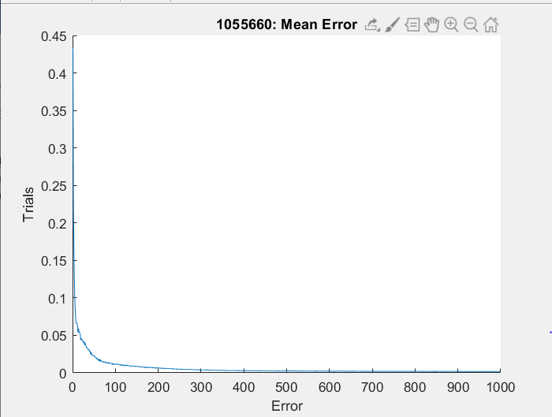

## 2.4. Test and interpret inverse model

### Neural network output

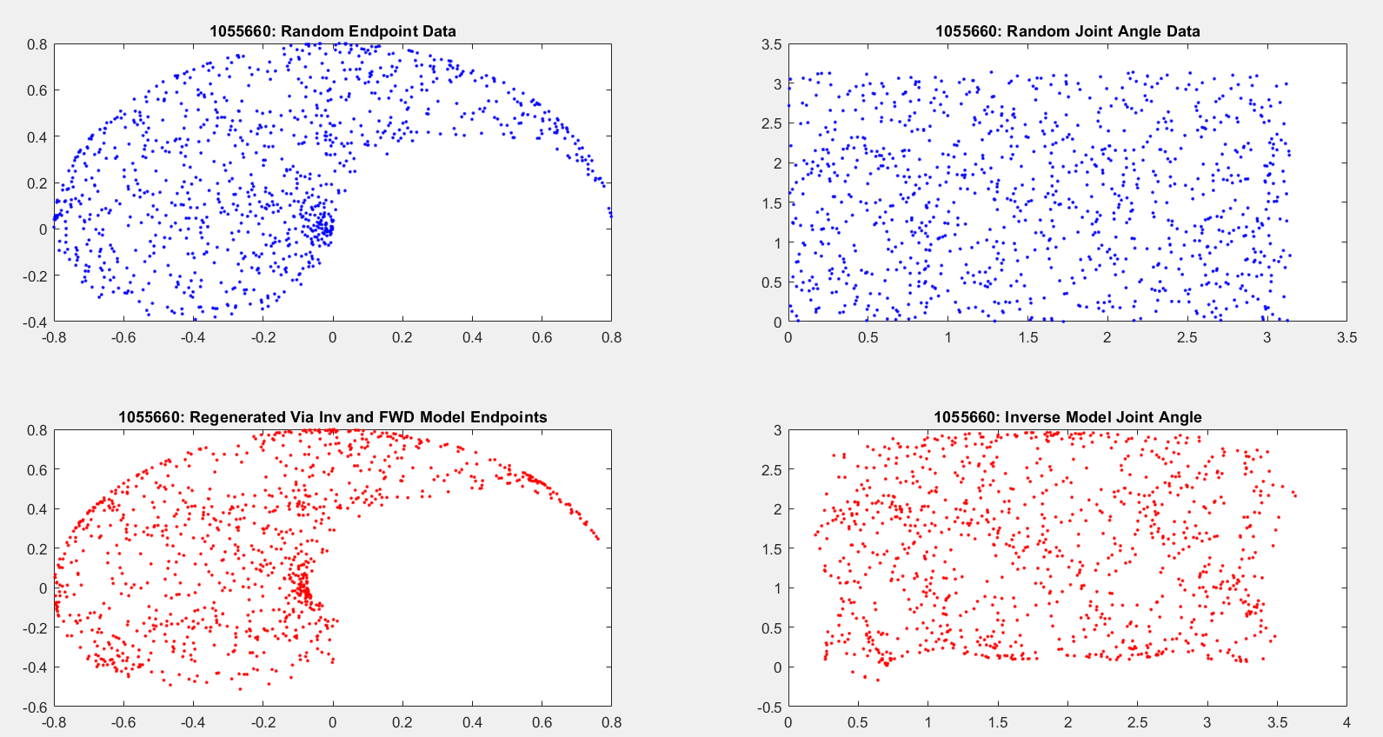

### Significance of this Plot:

This plot shows how well the neural network has been trained. As it’s doing inverse kinematics, it’s being shown the results of forward kinematics, and training the weights to change the input into the joint angles it’s being given as a target. The regenerated graph (graph4) puts those joint angles back through forward kinematics to show the usable positions the arm can reach.

### Are there better datasets to interpret inverse model performance?

The better option would be to use a dataset of data selected only within the range of the center of the largest area of the endpoint range. If the maze is scaled to the area mentioned, then the arm will never have to reach its limits. This means that the arm will always be able to reach a given input and avoid the areas the network had more error in training. Furthermore, if you train specifically in that area, training can be faster and more thorough, as you do not need to train it on data it won’t need.

### How can you make the dataset more representative of the maze task?

As previously stated, scaling the maze to the usable size of the arm and sampling only from that area will train the network to specifically handle that area, improving efficiency by not training the weights on useless data.

## Inline code

clc

close all

clear all

origin = [0;0]; %base frame of kinematics

length = [0.4,0.4]; % length of links

samples = 1000;% the number of samples used for training and testing

hidden = 12;%the number of hidden layers

input = 2;% number of system inputs

output = 2;% number of system outputs on the final layer

learningRate =0.001;

iterations = 50000;%number of times the network will be trained( a total of 50,000,000 data points will be used to train it)

[weight1, weight2]=makeWeights(output,hidden, input);% generate the weight matrices

for i = 1:iterations

%each iteration, a new set of training data will be generated. This

%will help the network generalize as it won’t be tuned to a specific

%dataset

targetData = rand([2,samples])*pi; % generate 1000 random angles from 0 to pi for each joint

[~,inputs] = RevoluteForwardKinematics2D(length,targetData,origin);%get the endpoint positions from the forward

%kinematics to be used as inputs for the inverse

[weight1, weight2,error]=Training(weight1, weight2,learningRate, inputs, targetData);%update the trained weights and output error matrix

meanError(i)=mean(error);% append the mean of the error matrix for future plotting

end

figure

hold on

title("1055660: Mean Error")

xlabel('Trials')

ylabel('Error')

plot(meanError)

%This will take the new weight matrices and test the data based off of the

%new testing data

randomAngles = rand([2,samples])*pi; % generate 1000 random angles from 0 to pi for each joint

[~,randomEndpoints] = RevoluteForwardKinematics2D(length,randomAngles,origin);%get the endpoint positions from the forward

[networkAngles,~] = feedForwardPass(weight1, weight2, randomEndpoints);% generate a set of joint angles

[~,networkEndpoints] = RevoluteForwardKinematics2D(length,networkAngles,origin);%generate the endpoint of the

%arm from the inverse kinematics' joint angles

figure

hold on

subplot(221)

plot(randomEndpoints(1,:),randomEndpoints(2,:),'.b')

title("1055660: Random Endpoint Data")

subplot(222)

plot(randomAngles(1,:),randomAngles(2,:),'.b')

title("1055660: Random Joint Angle Data")

subplot(223)

plot(networkEndpoints(1,:),networkEndpoints(2,:),'.r')

title("1055660: Regenerated Via Inv and FWD Model Endpoints")

subplot(224)

plot(networkAngles(1,:),networkAngles(2,:),'.r')

title("1055660: Inverse Model Joint Angle")

### Inline code and plots for smaller sample size

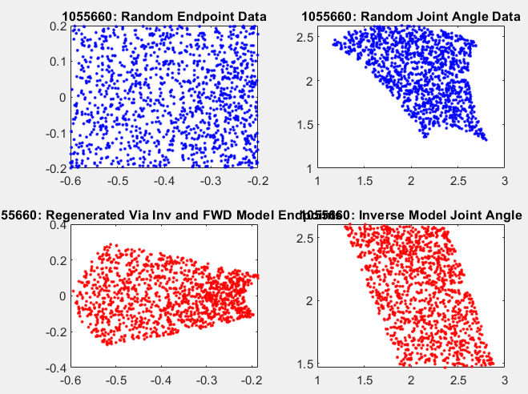

clc

close all

clear all

origin = [0;0]; %base frame of kinematics

length = [0.4,0.4]; % length of links

samples = 10000;% the number of samples used for training and testing

hidden = 5;%the number of hidden layers

input = 2;% number of system inputs

output = 2;% number of system outputs on the final layer

minX= -0.6;

minY=-0.2;

maxX=-0.2;

maxY=0.2;

learningRate =0.0001;

iterations = 10000;%number of times the network will be trained( a total of 50,000,000 data points will be used to train it)

[weight1, weight2]=makeWeights(output,hidden, input);% generate the weight matricies

for i = 1:iterations

%each iteration, a new set of training data will be generated. This

%will help the network generalize as it wont be tuned to a specific

%dataset

if mod(i,500) ==0

i

end

initialSamples = rand([2,samples])*pi; % generate 1000 random angles from 0 to pi for each joint

targetData = initialSamples;

[~,inputs] = RevoluteForwardKinematics2D(length,targetData,origin);%get the endpoint positions from the forward

a=find(inputs(1,:)<=maxX&inputs(1,:)>=minX);

inputs = inputs(:,a);

targetData = targetData(:,a);

b=find(inputs(2,:)<=maxY&inputs(2,:)>=minY);

inputs = inputs(:,b);

targetData = targetData(:,b);

%kinematics to be used as inputs for the inverse

[weight1, weight2,error]=Training(weight1, weight2,learningRate, inputs, targetData);%update the trained weights and output error matrix

meanError(i)=mean(error);% append the mean of the error matrix for future plotting

end

figure

hold on

title("1055660: Mean Error")

xlabel('Trials')

ylabel('Error')

plot(meanError)

%This will take the new weight matricies and test the data based off of the

%new testing data

randomAngles = rand([2,samples])*pi; % generate 1000 random angles from 0 to pi for each joint

[~,randomEndpoints] = RevoluteForwardKinematics2D(length,randomAngles,origin);%get the endpoint positions from the forward

a=find(randomEndpoints(1,:)<=maxX&randomEndpoints(1,:)>=minX);

randomEndpoints = randomEndpoints(:,a);

randomAngles = randomAngles(:,a);

b=find(randomEndpoints(2,:)<=maxY&randomEndpoints(2,:)>=minY);

randomEndpoints = randomEndpoints(:,b);

randomAngles = randomAngles(:,b);

[networkAngles,~] = feedForwardPass(weight1, weight2, randomEndpoints);% generate a set of joint angles

[~,networkEndpoints] = RevoluteForwardKinematics2D(length,networkAngles,origin);%generate the endpoint of the

%arm from the inverse kinematics' joint angles

figure

hold on

subplot(221)

plot(randomEndpoints(1,:),randomEndpoints(2,:),'.b')

title("1055660: Random Endpoint Data")

subplot(222)

plot(randomAngles(1,:),randomAngles(2,:),'.b')

title("1055660: Random Joint Angle Data")

subplot(223)

plot(networkEndpoints(1,:),networkEndpoints(2,:),'.r')

title("1055660: Regenerated Via Inv and FWD Model Endpoints")

subplot(224)

plot(networkAngles(1,:),networkAngles(2,:),'.r')

title("1055660: Inverse Model Joint Angle")

save('weights.mat', 'weight1','weight2');%save weights for faster implementation

# 3. Path Through a Maze

### Game board:

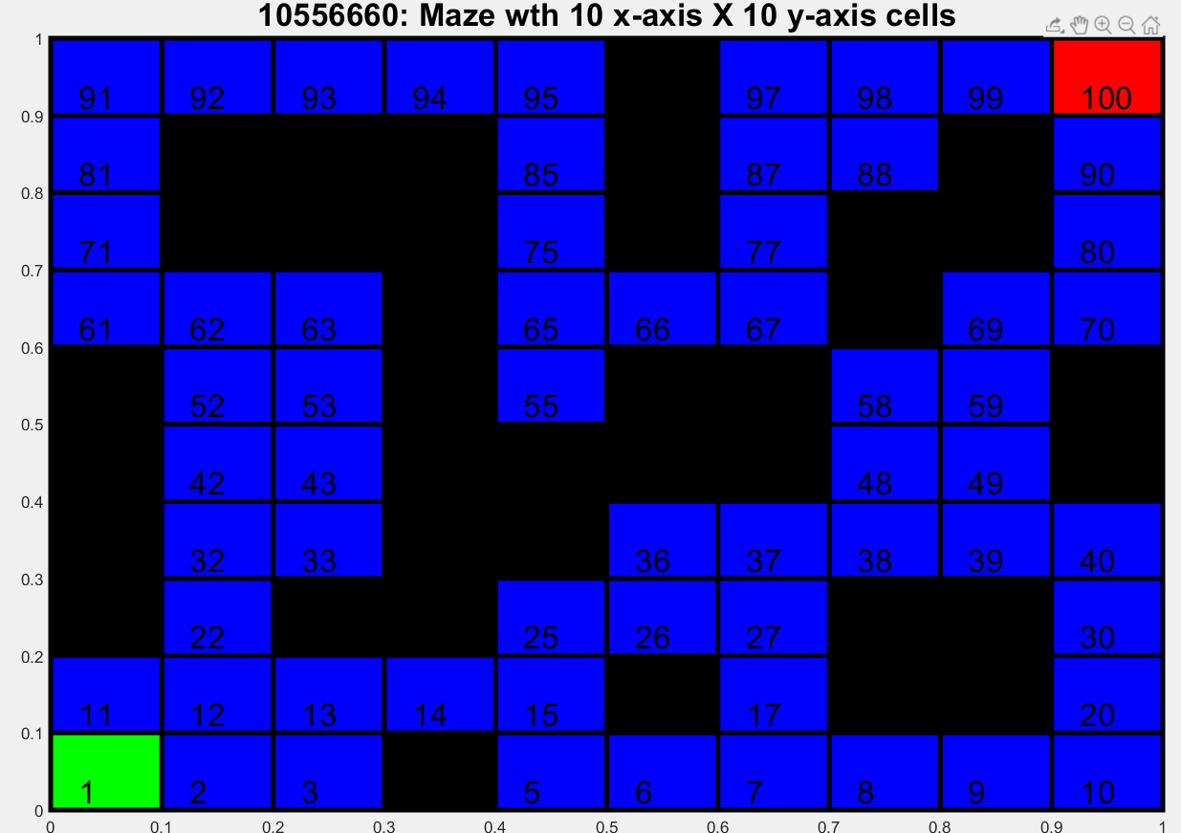

### Set Starting State and Blocked Locations

% specify start location in (x,y) coordinates

startLocation=[1 1];

% specify end location in (x,y) coordinates

endLocation=[10 10];

% specify blocked location in (x,y) coordinates

f.blockedLocations = [4 1; 6 2; 8 2; 9 2; 1 3; 3 3; 4 3; 8 3; 9 3; 1 4; 4 4; 5 4; 1 5; 4 5; 5 5; 6 5; 7 5; 10 5; 1 6; 4 6; 6 6; 7 6; 10 6;...

4 7; 8 7; 2 8; 3 8; 4 8; 6 8; 8 8; 9 8; 2 9; 3 9; 4 9; 6 9; 9 9; 6 10;];

## 3.1 Random start state

### Histogram:

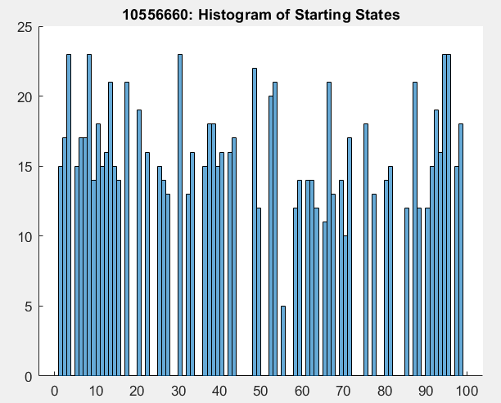

### Comment on how the displayed state occurrences align with the maze.

Any spaces that are empty, correspond with blocked and end states. As these are all random frequency of appearance indicates nothing.

### Inline code

#### Main code:

% test random start

startingIterations=1000;

for i = 1:startingIterations

histo(i) = maze.RandomStartingState();% add 1000 starting states to a list

end

figure

hold on

histogram(histo,[1:99])%plot the states in a histogram with whole number edges

title("10556660: Histogram of Starting States")

#### Random Starting State Function:

% function computes a random starting state

function startingState = RandomStartingState(f)

startingState = fix(rand*98)+1;% generate a number from 1-99(leaving out end state)

[x,y] = f.stateToCoords(startingState);% convert your state into a set of coordinates

[rows,~] =size(f.blockedLocations); % get the number of rows of the blockedLocation matrix

for i = 1:rows%iterate through each row of blockedLocation

if f.blockedLocations(i,:) == [x,y]%if any rows are equal to our X,Y coordinates

startingState = f.RandomStartingState();% then recursively call this function starting state isn't blocked

break

end

end

end

#### State to Coordinate Function

%function to give the coordinates of a given state

function [x,y] = stateToCoords(f,state)

state = state-1;%start arrays from 0

x = mod(state,10)+1; %get the remainder from dividing by 0

y = fix(state/10)+1;% divide by 0 without remainder

end

## 3.2 Build a Reward Function

### Inline code

% reward function that takes a stateID and an action

function reward = RewardFunction(f, state, action)

if state == 99 && action == 2 %if you are in 99 and go right

reward = 10;

elseif state == 90 && action == 1 %if you are in 90 and go up

reward = 10;

else % any other state and action

reward = 0;

end

end

## 3.3. Generate the transition matrix (5 marks)

### Inline Code:

#### Generator Script:

%% a script to generate a transition matrix autmatically and save it to a file for faster load times

blockedLocations = [4 1; 6 2; 8 2; 9 2; 1 3; 3 3; 4 3; 8 3; 9 3; 1 4; 4 4; 5 4; 1 5; 4 5; 5 5; 6 5; …

7 5; 10 5; 1 6; 4 6; 6 6; 7 6; 10 6;4 7; 8 7; 2 8; 3 8; 4 8; 6 8; 8 8; 9 8; 2 9; 3 9; 4 9; 6 9; 9 9; 6 10;];

% a list of blocked locations to correctly transition

states = 100;

actions= 4;

transitionMatrix = zeros(states,actions);%initialize an empty matrix to be filled

[bx,~]=size(blockedLocations);%get the number of blocked locations

%a list of action numbers and their directions:

%1 = north(up) ^

%2= east(right) >

%3= south(down) v

%4= west(left) <

for a = 1:actions

for s = 1:states%for each state and action

[x,y] = stateToCoords(s);%get the coordinates of the states

switch a% update next state based off the aforementioned directions

case 1

nextX=x;

nextY=y+1;

case 2

nextX=1+x;

nextY=y;

case 3

nextX=x;

nextY=y-1;

case 4

nextX=x-1;

nextY=y;

end

for b = 1:bx%for each blocked location

if (nextX>10 ||nextX<1||nextY>10||nextY<1||((nextX==blockedLocations(b,1))&&(nextY==blockedLocations(b,2))))

%if move exceeds bounds, or would enter a blocked state,

%return the original state

nextX=x;

nextY=y;

end

end

transitionMatrix(s,a)=coordsToState(nextX,nextY); %store the state value of the next state in the matrix

end

end

save('transitionMatrix.mat', 'transitionMatrix');%save the matrix to file for a direct import into the main code

%%%%%%%%%%%%functions below%%%%%%%%%%%%%%%

%function to give the coordinates of a given state

function [x,y] = stateToCoords(state)

state = state-1;%start arrays from 0

x = mod(state,10)+1; %get the remainder from dividing by 0

y = fix(state/10)+1;% divide by 0 without remainder

end

%function to give the state from the given coordinates

function state = coordsToState(x,y)

state = ((y-1)*10)+x;

end

#### Import into main

function f = BuildTransitionMatrix(f)

f.tm=load('transitionMatrix.mat', 'transitionMatrix');%pull the pre-generated transition matrix from file

end

## 3.4 Initialize Q values

### Inline code:

% init the q-table

function f = InitQTable(f)

% allocate

f.QValues = rand(f.xStateCnt * f.yStateCnt, f.actionCnt)/10;

%initialize Q values to a random number between 0 and 0.1

end

## 3.5 Implement Q-Learning Algorithm

### Inline Code:

trials = 100;% number of trials for this experiment

episodes =1000;%number of episodes per trial

explorationRate=% the rate at which the algorithm takes a random action

temporalDiscount =

learningRate =

stepscat=[];

for i=1:trials

maze = maze.InitQTable();%each trial init a clean random Q table

for j = 1:episodes

step = 0;% reset the number of steps and reward values for this episode

reward = 0;

state = 1;%RandomStartingState();

while reward == 0

oldState = state;% save the old state

step = step +1;% increment the number of steps take

action =actionSelect(maze.QValues,state,explorationRate)%generate the action the algorithm will take

%using epsilon greedy

state = maze.tm(state,action);% get the new state from the transition table

reward = maze.RewardFunction(oldState,action);%check if the algorithm gives a reward

maze.QValues(oldState, action)= maze.QValues(oldState, action) + learningRate...

*(reward+temporalDiscount*max(maze.QValues(state,:))-max(maze.QValues(oldState,:)));

%update your Qtable for the states and actions

end

steps(j) = step;% add the number of steps to a total for this trial

end

stepscat =[stepscat;steps];%concatenate each step count per trial

end

for i =1:episodes

means(i)=mean(stepscat(:,i));%take the mean for all step i per episode

STDeviations(i)=std(stepscat(:,i));%take the standard deviation for all step i per episode

end

%%%%%%%%%%%%%%%%%%%%%%%%%Functions%%%%%%%%%%%%%%%%%%%%%%%%

function [action] = actionSelect (table, state,explorationRate)

chance = rand(1);%chance to explore

if chance < explorationRate%if exploring

action = randperm(4,1);%give an action in whole numbers between 1 and 4

else %if not exploring

[~ , action] = max(table(state, :));%your action is the Highest Q value per the given state

end

end

## 3.6 Run Q-Learning

### Graph:

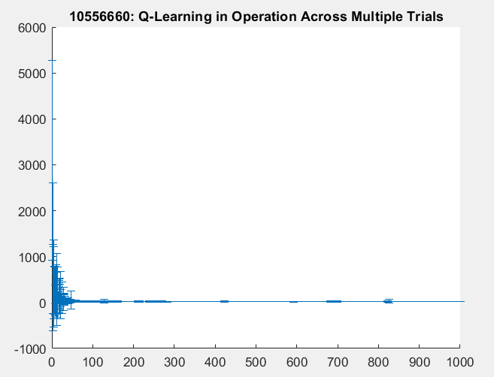

### Observations:

The graph shows that as the algorithm is trained, the number of steps quickly drops off. The standard deviation can fluctuate a bit randomly however, that is most likely due to the random exploration rate.

### Inline code:

trials = 100;% number of trials for this experiment

episodes =1000;%number of episodes per trial

explorationRate=0.1;% the rate at which the algorithm takes a random action

temporalDiscount = 0.9;

learningRate = 0.2;

totals=zeros(episodes);

stepscat=[];

for i=1:trials

maze = maze.InitQTable();%each trial init a clean random Q table

for j = 1:episodes

step = 0;% reset the number of steps and reward values for this episode

reward = 0;

state = 1;%RandomStartingState();

while reward == 0

oldState = state;% save the old state

step = step +1;% increment the number of steps take

action =actionSelect(maze.QValues,state,explorationRate)%generate the action the algorithm will take

%using epsilon greedy

state = maze.tm(state,action);% get the new state from the transition table

reward = maze.RewardFunction(oldState,action);%check if the algorithm gives a reward

maze.QValues(oldState, action)= maze.QValues(oldState, action) + learningRate...

*(reward+temporalDiscount*max(maze.QValues(state,:))-max(maze.QValues(oldState,:)));

%update your Qtable for the states and actions

end

steps(j) = step;% add the number of steps to a total for this trial

end

stepscat =[stepscat;steps];%concatenate each step count per trial

end

for i =1:episodes

means(i)=mean(stepscat(:,i));%take the mean for all step i per episode

STDeviations(i)=std(stepscat(:,i));%take the standard deviation for all step i per episode

end

%Graph your means and standard deviations

figure

hold on

errorbar(means, STDeviations)

title("10556660: Q-Learning in Operation Across Multiple Trials")

%%%%%%%%%%%%%%%%%%%%%%%%%Functions%%%%%%%%%%%%%%%%%%%%%%%%

function [action] = actionSelect (table, state,explorationRate)

chance = rand(1);%chance to explore

if chance < explorationRate%if exploring

action = randperm(4,1);%give an action in whole numbers between 1 and 4

else %if not exploring

[~ , action] = max(table(state, :));%your action is the Highest Q value per the given state

end

end

## 3.7. Exploitation of Q-values

### Graph

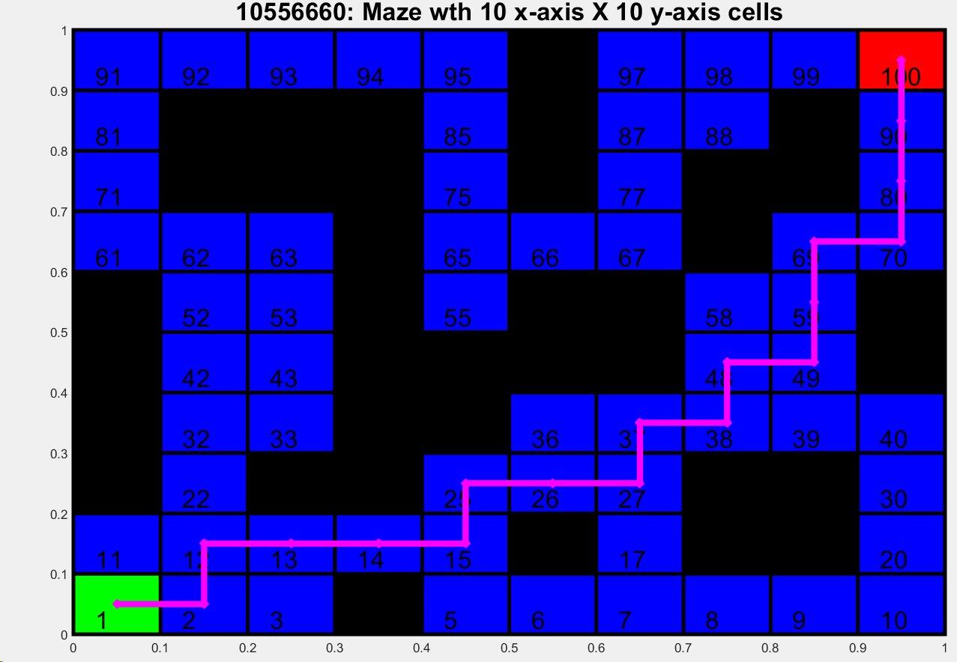

### Inline code

%%%%%%%%%%%%%%%No Explore run%%%%%%%%%%%%%%%%%%%%%%%%%%

%reset reward, state and step number

reward = 0;

i=0;

coords=[];

state =1;

%implement the previous code with a exploration rate of 0

%and no training. Keep notes of the XY coordinates of the given states

while reward == 0

i=i+1;

states(i) = state;% save the old state

step = step +1;% increment the number of steps take

action =actionSelect(maze.QValues,state,0);%implement the epsilon Greedy with 0 exploration rate

state = maze.tm(state,action);% get the new state from the transition table

reward = maze.RewardFunction(states(i),action);%check if the algorithm gives a reward

[x,y]=maze.stateToCoords(states(i));

coords=[coords,[x;y]];

end

coords = [coords,[10;10]];% since the code doesn't record the end state, tack it on the end

coords = (coords-0.5)/10;%scale the coordinates and make them look a little nicer

plot(coords(1,:),coords(2,:), 'mx-', 'linewidth',5)% plot them

# 4.Move Arm Endpoint Through Maze

## 4.1. Generate kinematic control to revolute arm

### Non animated arm motion:

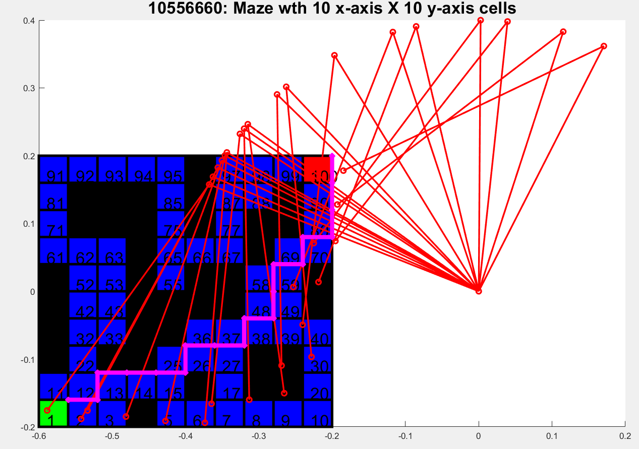

### Inline code:

Note: this code uses pre-generated and saved weights and Qvalues to speed up execution.

close all

clear all

clc

% scaled maze to the best trained area of the kinematics

minX= -0.6;

minY=-0.2;

maxX=-0.2;

maxY=0.2;

limits = [minX maxX; minY maxY;];

% build the maze

maze = CMazeMaze10x10(limits);

% draw the maze

maze.DrawMaze();

%%%%%%%%%%%%%%%%%%%%%%%%%%%%%%%%%%%%%%%%%%%%%%%%%%%%%%%%%

% load the q-table

maze = maze.loadQvalues();

%%%%%%%%%%%%%%%%%%%%%%%%%%%%%%%%%%%%%%%%%%%%%%%%%%%%%%%%%

% build the transition matrix

maze = maze.BuildTransitionMatrix();

%%%%%%%%%%%%%%%%%%%%%%%%%%%%%%%%%%%%%%%%%%%%%%%%%%%%%%%%%

%load weights from file

load('weights.mat')

%reset reward, state and step number

origin = [0;0]; %base frame of kinematics

length = [0.4,0.4]; % length of links

step =0;

reward = 0;

i=0;

coords=[];

state =1;

%implement the previous code with a exploration rate of 0

%and no training. Keep notes of the XY coordinates of the given states

while reward == 0

i=i+1;

states(i) = state;% save the old state

action =actionSelect(maze.QValues,state,0);%implement the epsilon Greedy with 0 exploration rate

state = maze.tm(state,action);% get the new state from the transition table

reward = maze.RewardFunction(states(i),action);%check if the algorithm gives a reward

[x,y]=maze.stateToCoords(states(i));

coords=[coords,[x;y]];

end

coords = [coords,[10;10]];% since the code doesn't record the end state, tack it on the end

%coords = (coords-0.5);%scale the coordinates and make them look a little nicer

coords(1,:)=(coords(1,:)*((maxX-minX)/10))-(abs(minX));

coords(2,:)=(coords(2,:)*((maxY-minY)/10))-(abs(minY));

[angles,~]= feedForwardPass(weight1,weight2, coords);

[P1,P2] = RevoluteForwardKinematics2D(length,angles,origin);

for j = 1:i

x = [origin(1),P1(1,j),P2(1,j)];

y =[origin(2),P1(2,j),P2(2,j)];

plot(x,y,'-or','linewidth',2)

end

plot(coords(1,:),coords(2,:), 'mx-', 'linewidth',5)

%%%%%%%%%%%%%%%%%%%%%%%%%Functions%%%%%%%%%%%%%%%%%%%%%%%%

function [action] = actionSelect (table, state,explorationRate)

chance = rand(1);%chance to explore

if chance < explorationRate%if exploring

action = randperm(4,1);%give an action in whole numbers between 1 and 4

else %if not exploring

[~ , action] = max(table(state, :));%your action is the Highest Q value per the given state

end

end

## 4.2 Animated revolute arm movement

Links: <https://youtu.be/fM-I6DbB_AA>

### Inline code

close all

clear all

clc

% scaled maze to the best trained area of the kinematics

minX= -0.6;

minY=-0.2;

maxX=-0.2;

maxY=0.2;

limits = [minX maxX; minY maxY;];

% build the maze

maze = CMazeMaze10x10(limits);

% draw the maze

maze.DrawMaze();

%%%%%%%%%%%%%%%%%%%%%%%%%%%%%%%%%%%%%%%%%%%%%%%%%%%%%%%%%%%%%%%%%%%%%%%%%%%

% load the q-table

maze = maze.loadQvalues();

%%%%%%%%%%%%%%%%%%%%%%%%%%%%%%%%%%%%%%%%%%%%%%%%%%%%%%%%%%%%%%%%%%%%%%%%%%%

% build the transition matrix

maze = maze.BuildTransitionMatrix();

%%%%%%%%%%%%%%%%%%%%%%%%%%%%%%%%%%%%%%%%%%%%%%%%%%%%%%%%%%%%%%%%%%%%%%%%%%%

%load weights from file

load('weights.mat')

%reset reward, state and step number

origin = [0;0]; %base frame of kinematics

length = [0.4,0.4]; % length of links

step =0;

reward = 0;

i=0;

coords=[];

state =1;

%implement the preivous code with a exploration rate of 0

%and no training. Keep notes of the XY coordinates of the given states

while reward == 0

i=i+1;

states(i) = state;% save the old state

action =actionSelect(maze.QValues,state,0);%implement the epsilon Greedy with 0 exploration rate

state = maze.tm(state,action);% get the new state from the transition table

reward = maze.RewardFunction(states(i),action);%check if the algorithm gives a reward

[x,y]=maze.stateToCoords(states(i));

coords=[coords,[x;y]];

end

coords = [coords,[10;10]];% since the code doesn't record the end state, tack it on the end

coords = (coords-0.5);%scale the coordinates and make them look a little nicer

coords(1,:)=(coords(1,:)*((maxX-minX)/10))-(abs(minX));

coords(2,:)=(coords(2,:)*((maxY-minY)/10))-(abs(minY));

[angles,~]= feedForwardPass(weight1,weight2, coords);

[P1,P2] = RevoluteForwardKinematics2D(length,angles,origin);

v = VideoWriter('armEndpoint.avi');

v.FrameRate=10;

open(v);

for j = 1:i

maze.DrawMaze();

set(gca,"color",'k')

xlim([minX maxX+0.2])

ylim([minY maxY])

hold on

x = [origin(1),P1(1,j),P2(1,j)];

y =[origin(2),P1(2,j),P2(2,j)];

%axis ([minX maxX+0.2 minY maxY])

plot(coords(1,:),coords(2,:), 'mx-', 'linewidth',5)

plot(x,y,'-or','linewidth',2)

%xlim([minX maxX+0.2])

%ylim([minY maxY])

writeVideo(v,getframe(gca));

close(gcf)

end

close(v)

%%%%%%%%%%%%%%%%%%%%%%%%%Functions%%%%%%%%%%%%%%%%%%%%%%%%

function [action] = actionSelect (table, state,explorationRate)

chance = rand(1);%chance to explore

if chance < explorationRate%if exploring

action = randperm(4,1);%give an action in whole numbers between 1 and 4

else %if not exploring

[~ , action] = max(table(state, :));%your action is the Highest Q value per the given state

end

end